- To locate frame on the page, either of the method can be used locator.contentFrame(), Page.frameLocator() or Locator.frameLocator()
Step to locate frame:
- First locate the frame element using any “Page” locator
- After locating frame element, use contentFrame() method to return “FrameLocator”
- Once “FrameLocator” reference is returned, it can be used to locate the element inside the frame.
- Unlike Selenium where focus has to be switched to particular frame, in Playwright we do not need to switch to the element. Once frame reference is received, its inner elements can be traced

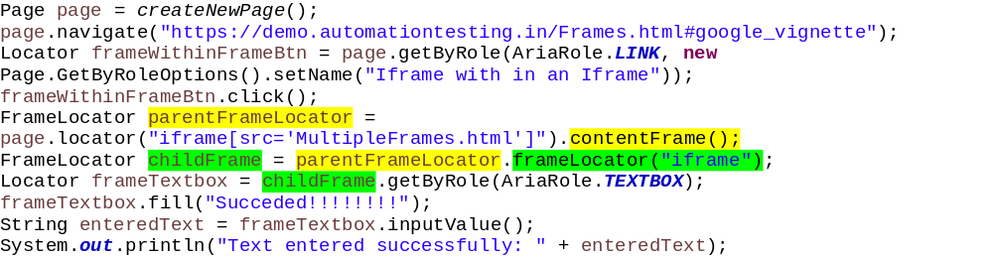
- To navigate to any of the frame from one frame to another, it does not require to switch like selenium. Playwright automatically handles that.
